# Deployment of war from JM to slave
-Anushka Vijay Gaikwad

- War file is already on JM and created slave-1
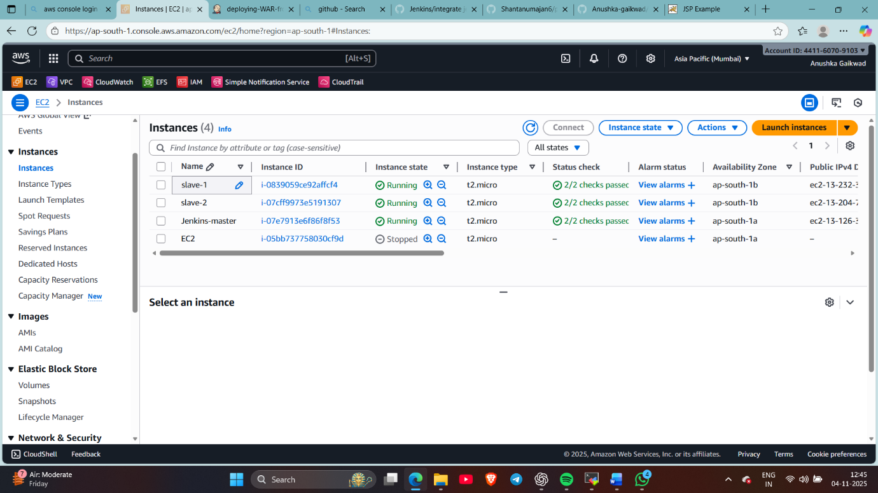
- Attached IAM role to both the JM and slave (EC2 to S3 full access)
- Installed java and maven on the slave
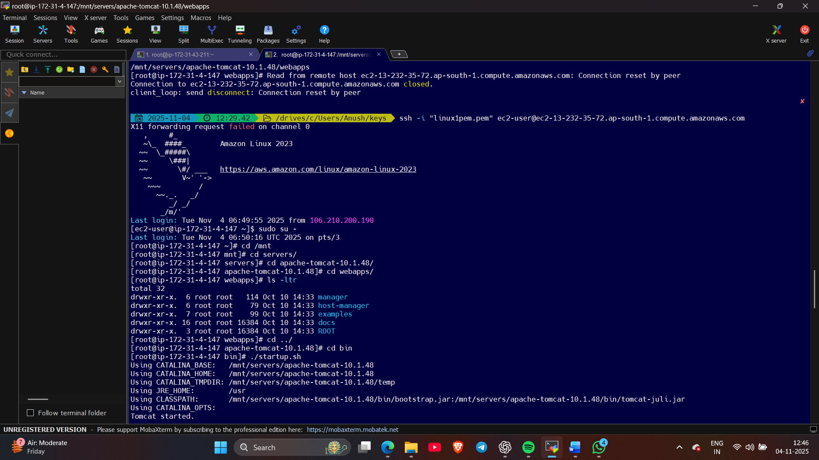
- Build a freestyle job : put project’s git repo and in shell script use commands to put war in S3 bucket
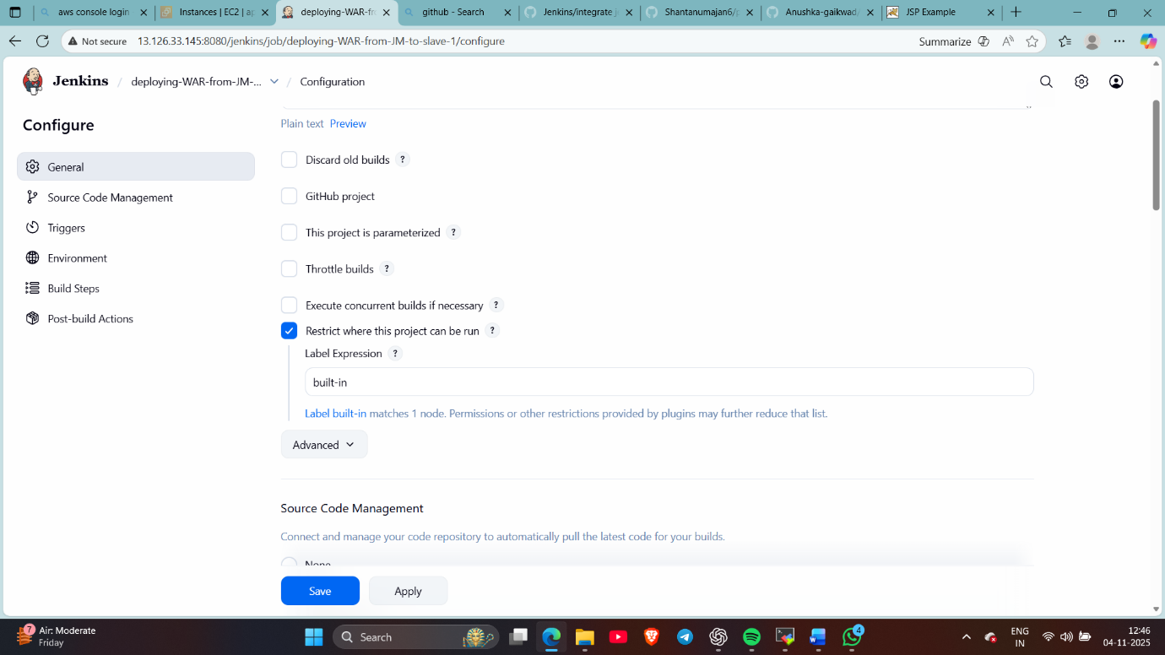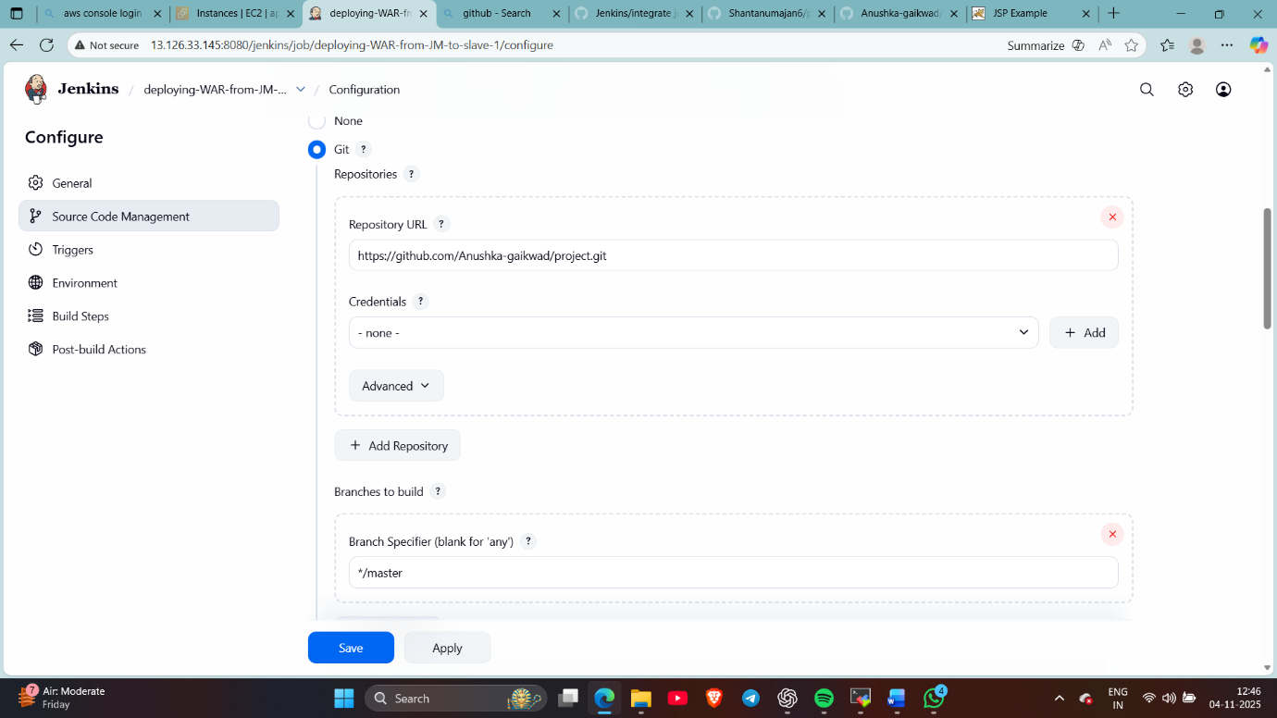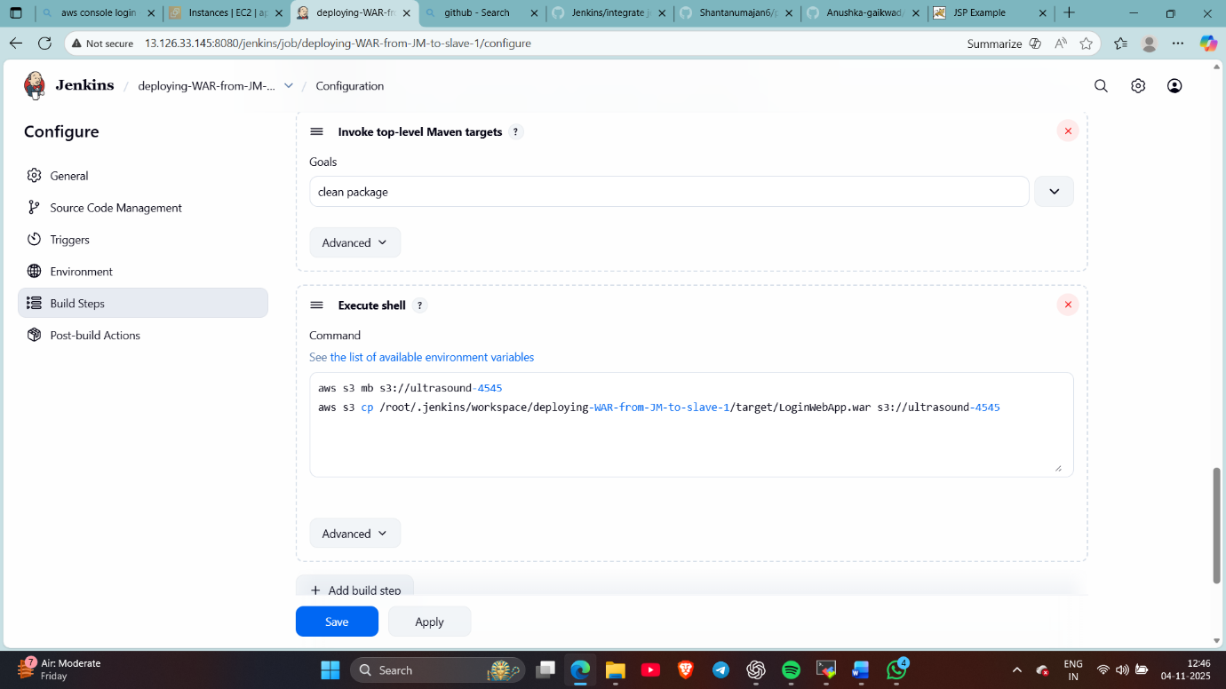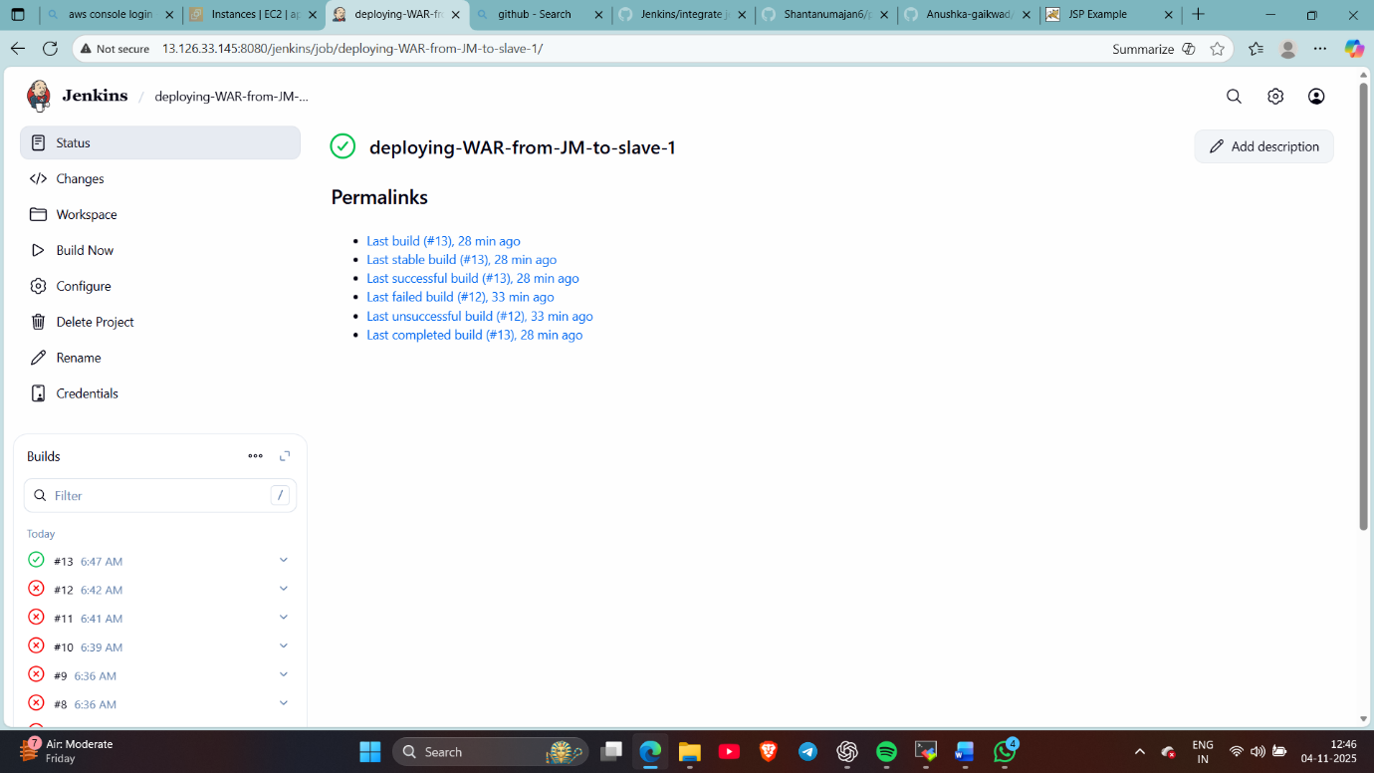
Now checked in slave
- Build another job in which war is copied from s3 bucket to the slave
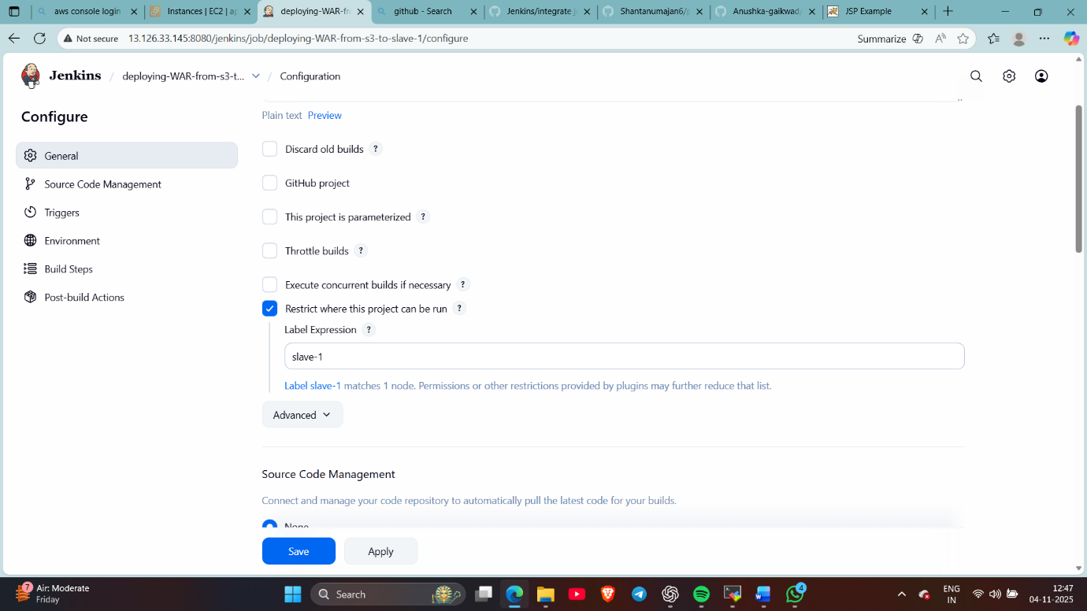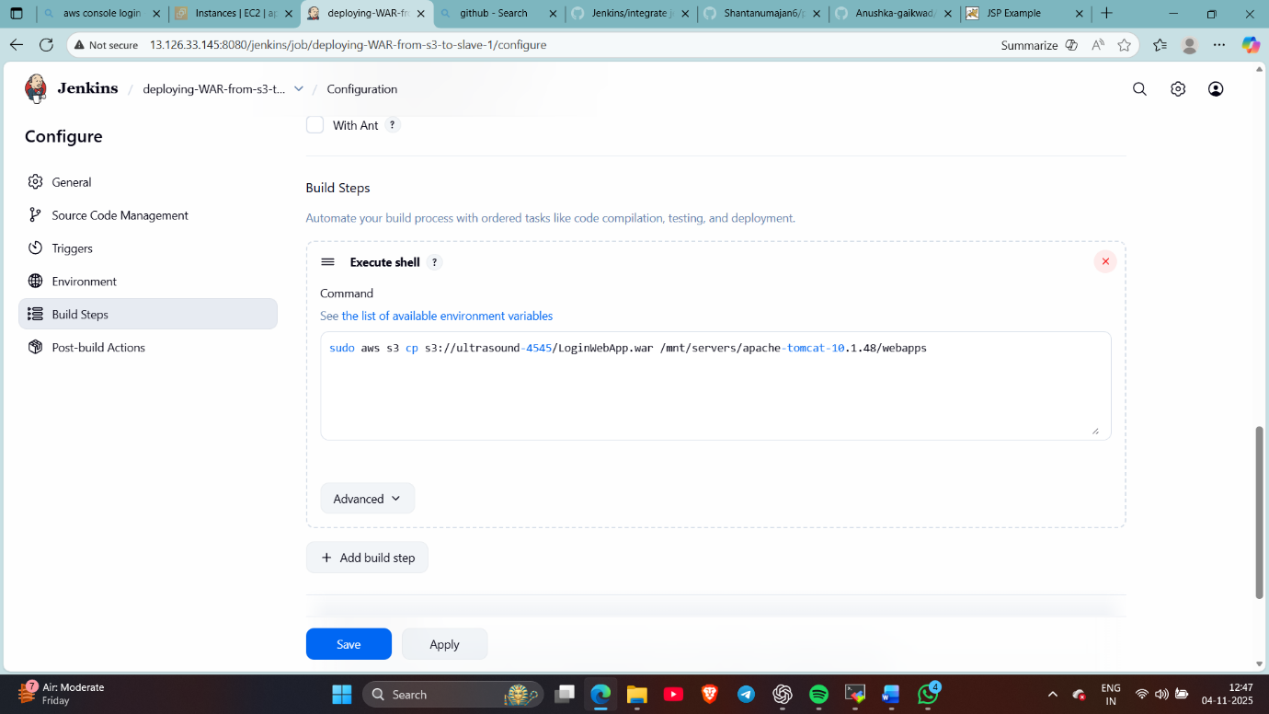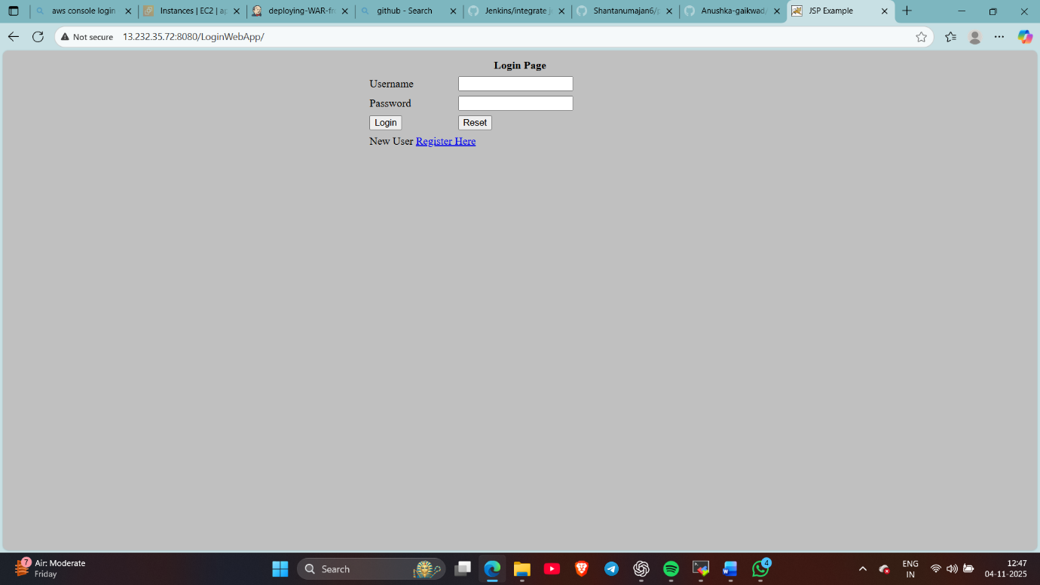
War is deployed on slave
sDone ..

